RESERVES POLICY 23/24
- Purpose: The purpose of the reserves policy is to ensure that Oldham boxing club maintains appropriate financial reserves to support its mission and objectives, manage risks, and provide financial stability.
- Reserve Levels: Oldham boxing club will maintain reserves in accordance with the following guidelines:
- The minimum level of reserves will be equivalent to 6 months of operating expenses.
- The optimum level of reserves will be equivalent to 12 months of operating expenses.
- The maximum level of reserves will be equivalent to 24 months of operating expenses.
- Reserve Management: The reserves will be managed in accordance with the following principles:
- The reserves will be held in secure and accessible accounts.
- The reserves will not be used to cover operating expenses unless in exceptional circumstances and with the approval of the Board of Directors.
- Any drawdown from the reserves will be reported to the Board of Directors, along with an explanation of the circumstances and reasons for the drawdown.
- Review: The reserves policy will be reviewed annually by the Board of Directors, in conjunction with Oldham boxing club's budgeting and planning process.

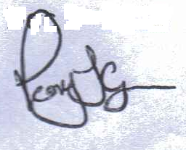 30/05/2023

