

Oldham Boxing Annual Report May 23 - May 2024

This year was another transformative year in the life of Oldham Boxing And Personal Development centre as we got closer embarking on our bold refurbishment project. Starting refurbishment project Nov 24. The refurbishment of our facility will begin in Nov/Dec We hope to get the refurbishment complete by mid 2025. Despite all of the disruption caused by the preparation.
We managed to deliver
- Eight boxing shows from Sep 2023 to Nov 2024 at Uppermill and Oldham Events Centre
- Became Charity on 9th May 2024 thanks to the support of Anthony Collins Solicitors
- Attracted new trustees and board members
- Achieved our Quality In Action Award from Action Oldham
- Hosted the Community Ownership Team from the Ministry Of Leveling Up

Governance
We became a charity in May and also had new trustees join our board. These include Mark Bradley and Eaton Fallows. Mark is a coach at the club and has stepped up to becoming a trustee.

Projects – Again This has been a year as being challenging as again the cost of living being the main challenge . But despite this we still managed to deliver our much needed services to the people and children of Oldham. As always There were many highlights in the year including delivering a plethora of projects.

- We move – GMP mentoring project
- Mahdlo – satellite gym
- Girls Project – with positive steps
- HAF – holiday sessions for children with healthy meals
- Sweaty Betty – Girls Only project targeting teenage Girls
- Cost of Living project – free family sessions on Saturday mornings
- Brit Theatre
Boxing Business
We have continued to an active boxing team containing registered twenty competitive boxers which continues to be diverse group of ethnic backgrounds, including a growing number of females boxers.Some of Our emerging team members have progressed onto bigger things with Kyle Tullin being the stand out story.mentoring is a meticulous journey that cannot be expedited. As a youth justice practitioner with over two decades of experience, I've discerned an unsettling inclination in the field. There's an increasing expectation for instantaneous results, often quantified by vast amounts of data. Such a perspective is not only impractical but also misaligned with the profound insights from landmark research such as the Glasgow Knife Crime study.The "public health approach" to violence advocates for a comprehensive perspective. It equates violence to a contagion, emphasizing interventions aimed at its roots rather than just addressing its manifestations. In sync with this approach, our philosophy is centered on sowing seeds of change, patiently nurturing them until they flourish.In today's rapid-paced world, there's a looming danger of haste, sometimes at the cost of depth and reflection. One might argue that a significant catalyst for individuals veering off-track is the whirlwind pace of the world they find themselves in. Genuine mentoring is a sustained commitment, unfolding over significant durations. It's an art and practice of patience, reflection, and critical thought – essentials we must uphold and advocate for in our work.The transformational power of mentoring can be witnessed in the journey of Kyle. Contrasting images capture the essence of his evolution: one from a harrowing night when he was on the brink of losing his life and the other marking a defining moment when he earned his Green Beret. The latter image not only symbolizes his personal growth but also stands testament to the efficacy of our mentoring approach. From moments of vulnerability to milestones of achievement, Kyle's story encapsulates the profound impact of sustained guidance, resilience, and belief. Stories like Kyle's are compelling testimonials of the work we do and the lives we touch through mentoring. The final image is of Kyle winning the Elite National Title !
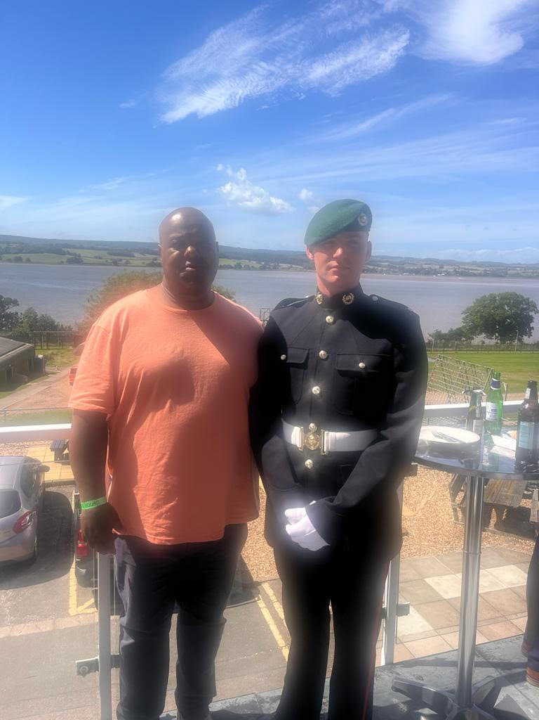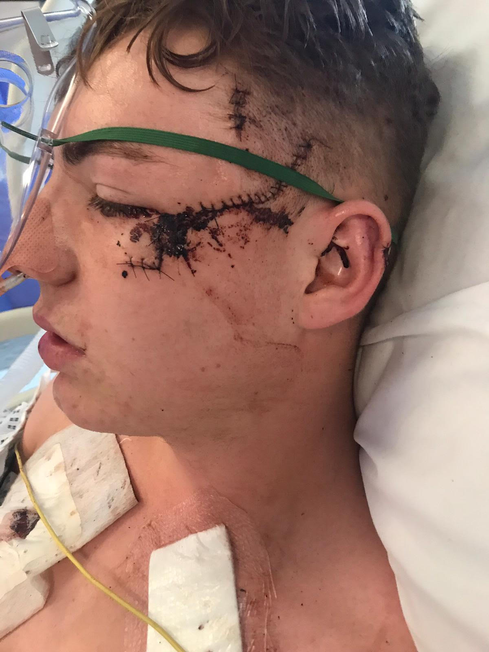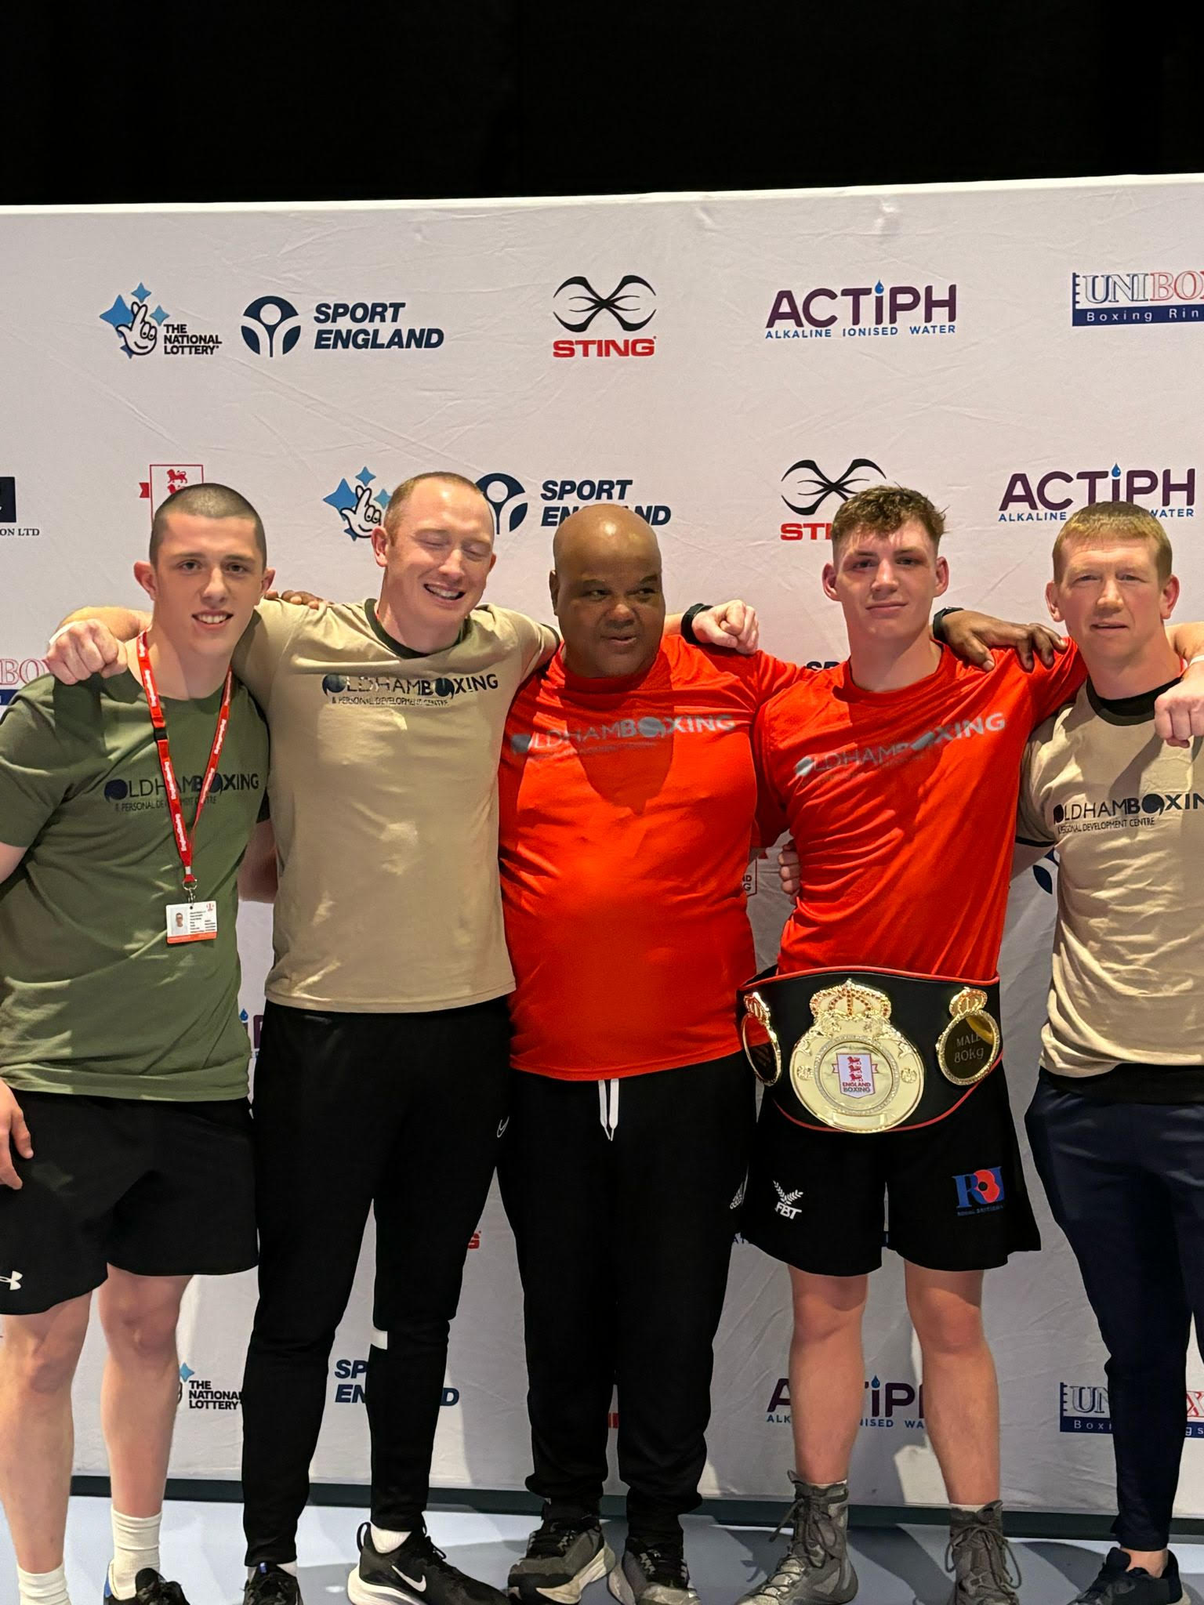

At OBPDC, we focus on personal development to ensure that we maximize our impact and are most effective in supporting young people to reach their full potential.Our recreational boxing attendance is still also also thriving and again attendees come from diverse backgrounds we hold four sessions a week with one female-only session (See KKP Report)Alongside our gym sessions, we also hold sessions in our boxing gym based in the Youth ZoneMahdlo. The attendance in this gym is in the hundreds per week. We also offer daytime alternative provision to young people not in school on Wednesday, a service that we are looking to expand
PROJECTS.
As always despite the added pressure Refurbishment Projects we have managed to deliver a plethora of other projects.We Move-A Pioneering GMP led mentoring projectMahdlo- Satellite Gym we operate and deliver sessions twice a week at the Youth ZoneEdstart-Alternative Education we deliver boxing sessions to young people not attending schoolGet Up And Get Out-Delivered in partnership with Positive Steps focused on vulnerable
teenage girls
Holiday Activity Project- We have been commissioned to deliver both holiday activities and
provide food to young people in receipt of free school meals in Oldham
Ministry Of Justice Project-We were commissioned by the Ministry Of Justice to deliver
specific activities to a targeting those at risk of offending
Sweaty Betty -Girls Only Project A project targeting teenage girls
Cost Of Living Project-We offer free sessions on Sunday morning

Refurbishment Project
As mentioned we will embark on a bold refurbishment project.l
PARTNER ORGANISATIONS
In order to maximize our reach and impact OBPDC has always collaborated with other
organizations and throughout last year we worked with a plethora of organizations new partners include The Royal Marines
- Greater Manchester Police
- Royal Marines
- The Open University
- Ear To The Ground
- Street Games
- National Association of Boys And Girls Clubs
- Mahdlo Youth Zone
- The Diane Model Foundation
- Keep Our Girls Safe
- Early Break
- 42nd Street
- Action Together
- Youth Service
- Positive Steps
- Oldham Enterprise Plus

Staffing
Despite the tremendous output, people think we are a much bigger organization than we are when it comes to staff! We still only have one full time and one part time dministrator.

